**4K+1080P+1080P Dashcams**

**ZD83** Manual

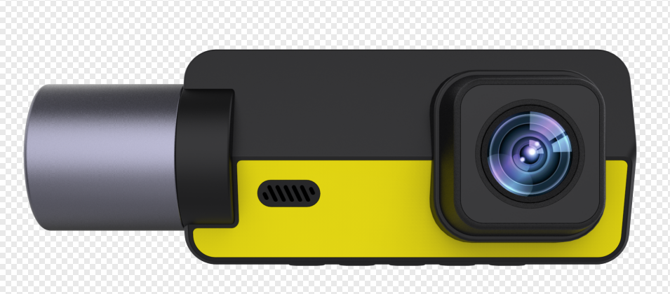

**Notice**

* Use the car charger provided by us to charge the device or hardware kit. Unsuitable car charger or hardware kit can damage the built-in battery or even encounter danger.
* Never disassemble the device or remove the built-in battery by yourself. Can only be handled by professionals
* Do not put the device in the fire.
* Do not use the adapter in a humid environment, and do not touch the charger when your hands and feet are wet
* Do not repair the product without authorization. If the machine is damaged or in a humid environment, please replace it with a new one
* Prepare a SD card before using it. Please use a high-speed TF card (Class10 or higher) with a capacity of no less than 512MB, and the TF card supports a maximum of 128GB.
* TF cards need to be formatted on computers and other devices before being used for the first time.

**Production Diagram**

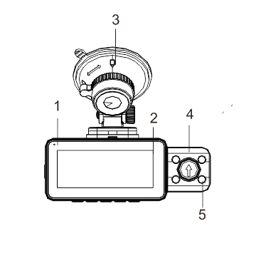

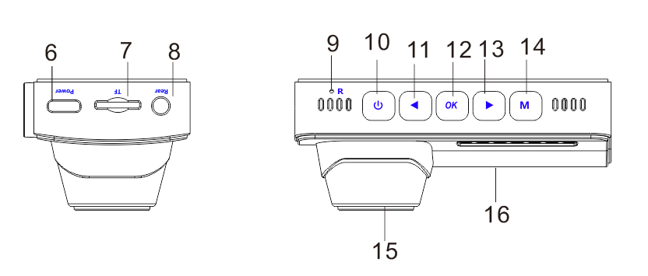

1.LED Indicator

2.Display Screen

3.Suction Cup Bracket

4.Interior Cam

5. IR LED

6.Type-C port

7.TF card slot

8.Rear Cam Port

9. Power button

10. Reset Button

11. Up button( Page up/Lock file/Switch WiFi )

12. OK button( Confirmation / Recording )

13. Down button( Page down/Switch Screen/ Audion on off )

14. M button( Menu / Switch mode / Photo )

15.Front Cam

16.Speaker

|  |  |  |
| --- | --- | --- |
| Name | Photo | Function Explanation |
| Power button( Screen On Off ) |  | 1. Long press 2S to turn on/off  2. When turned on: Short press to turn on/off the screen function |
| Up button( Page up/Lock file/Switch WiFi ) |  | 1. Menu/Playback Preview: Short press to scroll up  2. In recording mode: Short press to lock or unlock the video  3. In recording/preview mode: Long press to turn on/off WiFi  4. Video playback: Short press fast forward during playback |
| OK button( Confirmation / Recording ) |  | 1. Menu/playback mode: Short press to confirm function  2. In recording mode: Short press to start/stop recording |
| Down button( Page down/Switch Screen/ Audion on off ) |  | 1. Menu/Playback Preview: Short press to scroll down  2. In recording/preview mode: Short press to switch between pre recording, internal recording, post recording, three shot screen/pre recording, internal recording or post recording, two shot screen  3. In recording mode: Long press to turn on/off the recording function  4. Video playback: Short press to rewind during playback |
| M button( Menu / Switch mode / Photo ) |  | 1. Short press to enter and exit menu settings  2. Long press to switch mode  3. In recording mode: Short press to take a photo |

**Set up and Installation**

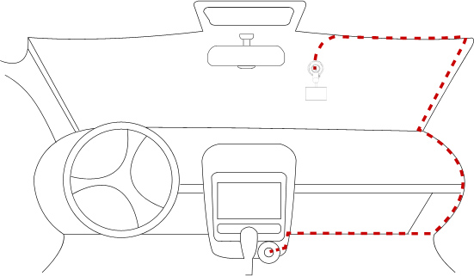

1.Use a 3M bracket or suction cup bracket to install the ZD60 DASH CAM on the windshield. The recommended location is near the rear view mirror near the passenger seat. Adjust the two lens angles to obtain the best coverage.

2. Connect the attached power adapter with the vehicle cigarette lighter socket, the indicator light will shine to indicate the power is turned on.

3.Connect the power adapter and dash cam, and arrange the redundant cables for a better look.

4.When starting the car, the DASH CAM will automatically power on. Check the lens angle and coverage to ensure that all functions are normal.

**Function Description**

**Power on/off:**

1. Power on: Press and hold the power button for 2 seconds or connect the power adapter, the device will automatically enter the recording mode.

2. Power off: In the power-on state, press and hold the power button for 2 seconds, it will shut down the machine. The device will automatically shut down after a car fault occurs and when the car stalls and the power supply is stopped.

**Video Recording mode:**

1. Insert the TF card into the driving record, and the device will automatically enter the recording mode when turned on. The red indicator light on the front of the driving record will light up and flash. The recording icon will turn red and flash, indicating that the device is recording normally.
2. Press the key OK to stop recording, and the red indicator light on the front of the driving record will stop flashing. The red icon will disappear, indicating that the device has stopped recording when the icon \\192.168.3.54\工程\项目资料\ZD59\ZD59  3.16寸屏按键版本UI\ZD57  3.16寸屏按键版本UI\assets\Video Icon.bmpappears .
3. Press the key OK again will start device recording again.

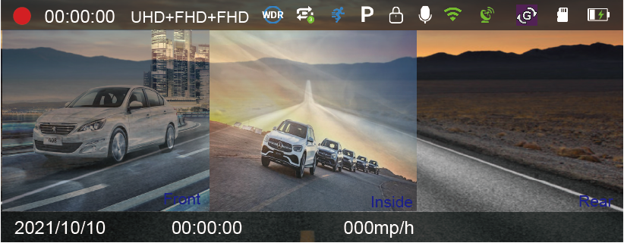

**Photo Mode:**

During the recording process, long press and hold the M key with a click to indicate taking a photo.

**Playback Mode:**

1. When the dash cam is in standby mode (when recording is stopped), press the M key to enter playback mode.

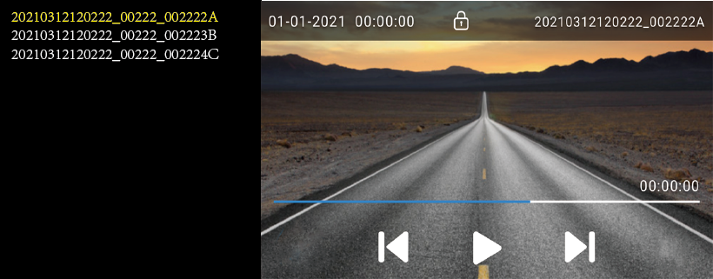

2.Press the up/down button to select the file you want. If you want to play a video , press the key OK to play the video.

3.In the playback preview interface: Short press the key M to enter the playback settings menu

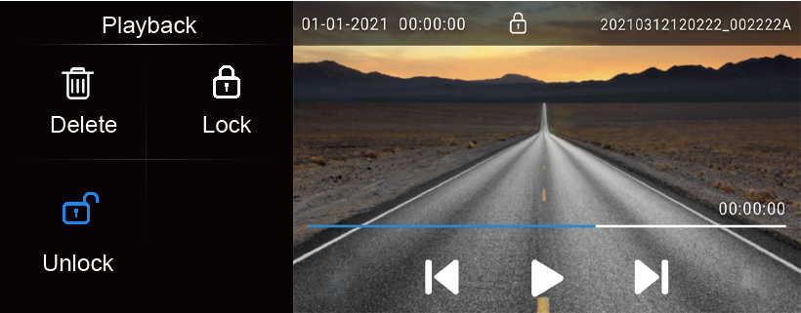下

**Setting Menu**

* Video Resolution

3840x2160P 30FPS

2560x1440P 30FPS

1920X1080P 30FPS

2160P+1440P 24FPS

2160+1080P 30FPS

1440P+1080P 30FPS

1080P+1080P 30FPS

2160P+1080P+1080P 30FPS

1440P+1080P+1080P 30FPS

1080P+1080P+1080P 30FPS

* Loop Recording

Off/1Minute/2Minute/3Minute

System default: 1 minute

* Exposure

-2.0、-5/3、-4/3、-1、-2/3、-1/3、+0.0、+1/3、+2/3、+1、+4/3、+5/3、+2.0

System default：+0.0

* WDR

On/Off

System default：On

* Screen Saver

Close/1Minute/3Minute/5Minute/10Minute

System default：Close

* Parking Monitor

Off/Motion Detection /Timelapse video/Parking Guard

System default：Off

1. When using hardware kit for power supply, if you select Parking Monitoring, disconnect the ACC, and the machine shuts down. In the event of a collision, the machine performs normal parking monitoring video with the status bar icon "P". Note: Parking monitoring automatically stops recording 30 seconds after each collision triggers machine recording; "If choose timelapse record, disconnect the ACC, and the video resolution will automatically jump to 1080P. Perform a 1-second recording of 2 FPS and 24H monitoring. The icon in the video recording status bar is" 缩时录影28".

2. When charging by car charger, timelapse record is invalid. When returning to the menu interface, the status bar icon displays as a timelapse record icon, but the recorded video is a normal video.

3. In both power supply modes, parking monitoring and timelapse record function can be turned off.

* Gravity Sensing

Off/Low/Middle/High

System default：Low

* Recording Audio

On/Off

System default：On

* Key Sound

On/Off

System default：On

* Language

ZH-CN,ZH-TW,ZH-HK,EN,ES,FR,PT,DE,IT,RU,JA,KO.

System default：EN

* Date and Time

Day/month/year time can be set, and 12H system and 24H system can be selected

* WiFi

On/Off

System Default：Off

* Auto Power Off

Options: Off/1min/2min/3min/5min/10min

* Light Frequency

60Hz/50Hz

System default：60Hz

* Image rotation

Off/On

System default: Off

AHD external camera image mirroring

* In-car Mirror

On/Off

System default：On

* Night view

Automatic/On/Off

System default: automatic

* Speed Unit

KM/H、MP/H

* Summer Time

Off/On

System default: Off

* GPS

On/Off

* Time zone

Time zone: The default+8:00 option includes 24 time zones (all time zones worldwide) to choose from, which can be set according to the time zone of your own country.

* Format  
  This function will format (erase all data) in the Micro SD Card.  
  **Warning: When formatting the card, all files will be erased. Upload all files you would like to save to your PC BEFORE you start to format the card.**
* Restore Factory Setting
* Yes/No, confirm whether to restore factory settings
* Version: View the current system version number

**Playback Setting:**

* delete

Delete current file

Delete all unlock files

* Locked files will not be deleted. To delete locked files, firstly need to unlock them.
* Lock

Lock file

Lock all files

* Unlock

Unlock file

Unlock all files

**Install and use WIFI:**

1. Download APP “WitCam Pro” from App store and Google Play
2. Press M key to enter system to set up, choose WIFI and open WIFI, it will show SSID name and password in the led display.
3. Open phone set up, and find SSID name (default password is 12345678),input password, and connect WIFI.
4. Open app “WitCam ” in the phone, click and add the device , it can connect to dash camera, then control taking photos, recording by smartphone

WitCam APP downloaded address:

<https://play.google.com/store/apps/details?id=com.zj.witcampro>

https://apps.apple.com/us/app/witcam/id1561751325

**Install and use GPS player:**

To view the GPS map using a mobile phone APP, you need to download the video file in the Dash Camera to the mobile phone for normal viewing. Download the player from below link and install 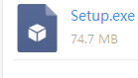, then open GPS video, with the downloaded player to play it.

GPS player downloaded address.

http://www.ligoor.com/app/witcam/witcampc.html

**Connect Computer:**

1. Connect the supplied USB Connection Cable to the Mini USB Port on the side of the unit.

2. Connect the full size USB end of the cable to a USB Port on the Computer.

3. The unit will automatically power on and display USB modes: “Mass Storage”.

4. Wait a few moments, the storage folder for the unit will appear on the computer screen.

5. Follow the on-screen instructions to view, watch, upload or save the files to the PC.

**NOTE:**

**Compatible computer operation system: Windows XP; Windows Vista; Windows 7; Windows 8 and Windows 10.**

**Specification**

|  |  |
| --- | --- |
| Name | Parameters |
| **CPU** | NT98529 |
| **Sensor** | Front IMX335/In-car IMX307/Rear cam AHD1080P |
| **Display** | 3.16 Inches MIPI 820*RGB*320 |
| **Video format** | MP4 |
| **Video Compressed format** | H.265 |
| **Video Mode** | Normal，loop |
| **Photo format** | JPEG |
| **Loop recording** | Off/1Minute/2Minutes/Minutes/5Minutes/10Minutes |
| **Parking monitoring** | 24H |
| **G-sensor** | Off/Low/Medium/High |
| **G-sensor lock** | Support |
| **HDR** | Support |
| **ADAS** | N/A |
| **Night vision** | Support |
| **GPS** | Support |
| **WiFi** | Support |
| **Language** | ZH-CN,ZH-TW,ZH-HK,EN,ES,FR,PT,DE,IT,RU,JA, |
| **Support Max card** | 256G( Class 10 above) |
| **USB interface** | Type-c |
| **OS** | Windows XP/Win7/Win10/Mac OS |
| **Power** | DC 5V 2A |
| **Storage Temperature** | （-30℃---70℃） |
| **Operation Temperature** | （-20℃---60℃） |